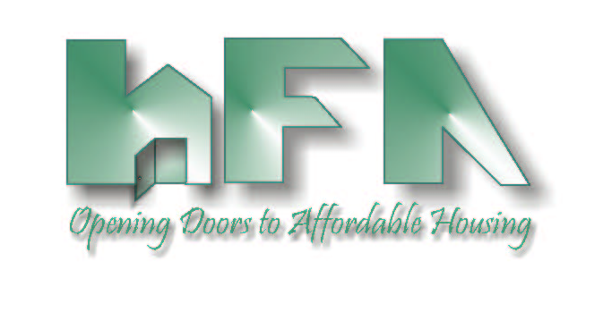
HILLSBOROUGH COUNTY
HOUSING FINANCE AUTHORITY

Board Members: c/o Mary Helen Farris, Esq.
Hillsborough County Attorney's Office
David A. Hollis, Chairman 601 East Kennedy Blvd., 27th Floor
Edward A. Busansky, Vice Chairman Tampa, FL 33602
Frank D. DeBose, Secretary www.hillsboroughcountyhfa.org
Mercedes B. DiMaio, Emeritus
Harry S. Hedges
Michael F. Kelley
Debra F. Koehler

DATE: July 7, 2020

TO: Board of Directors
Housing Finance Authority of Hillsborough County

FROM: Mark Hendrickson

SUBJECT: Agenda, July 15, 2020 Meeting of the Housing Finance Authority of Hillsborough County Board of Directors

Location: TELEPHONIC MEETING
Call-in number: 866.569.3761
Passcode: 8537016177

Enclosed is the Housing Finance Authority (HFA) Agenda for the Board meeting scheduled for Wednesday, July 8, 2020 at 12:30 p.m.

Please call Mark Hendrickson at (850) 671-5601, if you have any questions.

HOUSING FINANCE AUTHORITY OF HILLSBOROUGH COUNTY
AGENDA
9:30 a.m. Wednesday, July 15, 2020 Telephonic
- 12:30 P.M.: CALL TO ORDER, ROLL CALL & PLEDGE OF ALLEGIANCE

- STATEMENT
Welcome to a Board Meeting of the Housing Finance Authority of Hillsborough County. All meetings of the Authority are open to the public. Anyone who might wish to appeal any decision made by the Authority regarding any matter considered at the meeting is hereby advised that they will need a record of the proceedings, and for such purpose, they may need to assure that a verbatim record of the proceedings is made which will include the testimony and the evidence upon which such appeal is to be based. When addressing the Authority, please state your name and address and speak clearly.

- PUBLIC COMMENTS
- Speakers must provide their contact information and topic of their concern/presentation.
- Each individual is limited to a maximum of 3 minutes.

- UPDATE ON COUNTY-CITY AGREEMENT ON 9% HOUSING CREDITS
- Draft Agreement
- City Response
- Recommendations

