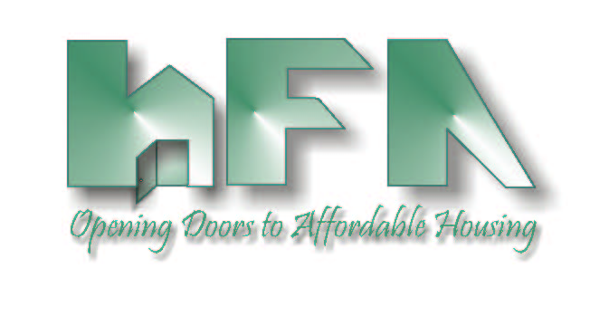
HILLSBOROUGH COUNTY
HOUSING FINANCE AUTHORITY

Board Members: c/o Mary Helen Farris, Esq.
David A. Hollis, Chairman Hillsborough County Attorney's Office
Edward A. Busansky, Vice Chairman 601 East Kennedy Blvd., 27th Floor
Frank D. DeBose, Secretary Tampa, FL 33602
Mercedes B. DiMaio, Emeritus www.hillsboroughcountyhfa.org
Tammy Haylock-Moore
Harry S. Hedges
Michael F. Kelley
Debra F. Koehler

DATE: February 4, 2021

TO: Board of Directors
Housing Finance Authority of Hillsborough County

FROM: Mark Hendrickson

SUBJECT: Agenda, February 12, 2021 Meeting of the Housing Finance Authority of Hillsborough County Board of Directors

Location: Planning Commission Board Room
County Center, 18th Floor
601 East Kennedy Boulevard
Tampa, FL 33602

THE PUBLIC IS STRONGLY ENCOURAGED TO PARTICIPATE VIA CONFERENCE CALL
Call-in number: 866.569.3761
Passcode: 8537016177

Enclosed is the Housing Finance Authority (HFA) Agenda for the Board meeting scheduled for Friday February 12, 2021 at 9:30 a.m.

Please call Mark Hendrickson at (850) 671-5601, if you have any questions.

HOUSING FINANCE AUTHORITY OF HILLSBOROUGH COUNTY
AGENDA
9:30 a.m. Friday, December 11, 2020
The County Center, 18th Floor for Board- Telephonic for Public

- 9:30 A.M.: CALL TO ORDER, ROLL CALL & PLEDGE OF ALLEGIANCE

- STATEMENT
Welcome to a Board Meeting of the Housing Finance Authority of Hillsborough County. All meetings of the Authority are open to the public. Anyone who might wish to appeal any decision made by the Authority regarding any matter considered at the meeting is hereby advised that they will need a record of the proceedings, and for such purpose, they may need to assure that a verbatim record of the proceedings is made which will include the testimony and the evidence upon which such appeal is to be based. When addressing the Authority, please state your name and address and speak clearly.

- MINUTES
- Consideration of Approval of December 11, 2020 Minutes

- PUBLIC COMMENTS
- Speakers must provide their contact information and topic of their concern/presentation.
- Each individual is limited to a maximum of 3 minutes.

- MONTHLY FINANCIAL STATEMENTS & INVESTMENTS
- Consideration of Approval December 2020 & January 2021 Financial Statements
- Update on Investments

- BOND ALLOCATION

- SINGLE FAMILY PROGRAMS
- DPA and TBA Loan Program Update

- LOCAL GOVERNMENT CONTRIBUTION FOR 9% HOUSING CREDITS

- RENTAL DEVELOPMENTS
- Update of 4% Housing Credit Rate
- Consider Final Approvals for Boulevard Towers IV
- Consider Amendment to Inducement Resolution for Millennia Portfolio
- Update on Upcoming Financings
- Consider Extension of Maturity Date and Subordination Agreement for The Preserve at Sabal Park
- Update on Existing Rental Developments

- SPECIAL PROGRAMS
- Up & Out Homeless Program
- Youth Aging Out of Foster Care Program
- Catholic Charities Program
- COVID-19 Rental Assistance Program
- USF CRED Training

- REPORTS
- Sadowski Education Effort/Legislative Update
- Florida Housing Finance Corporation
- Hillsborough County

- NEW BUSINESS

