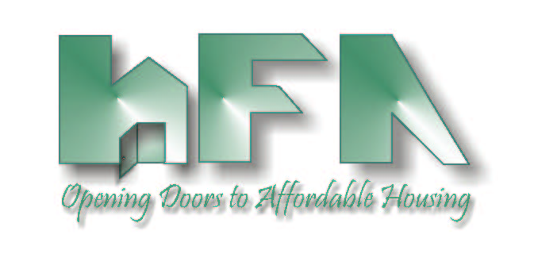
HILLSBOROUGH COUNTY
HOUSING FINANCE AUTHORITY

Board Members: c/o Mary Helen Farris, Esq.
Edward A. Busansky, Chairman Hillsborough County Attorney's Office
Frank D. DeBose, Vice Chairman 601 East Kennedy Blvd., 27th Floor
Tammy Haylock-Moore, Secretary Tampa, FL 33602
Harry S. Hedges www.hillsboroughcountyhfa.org
David A. Hollis
Michael F. Kelley
Debra F. Koehler

DATE: August 18, 2022

TO: Board of Directors
Housing Finance Authority of Hillsborough County

FROM: Mark Hendrickson

SUBJECT: Agenda, August 26, 2022, Meeting of the Housing Finance Authority of Hillsborough County Board of Directors

Location: Planning Commission Board Room
County Center, 18th Floor
601 East Kennedy Boulevard
Tampa, FL 33602

Enclosed is the Housing Finance Authority (HFA) Agenda for the Board meeting scheduled for Friday August 26, 2022, at 9:30 a.m.

Please call Mark Hendrickson at (850) 671-5601, if you have any questions.

This is an in-person meeting. There will not be a conference line for the public.

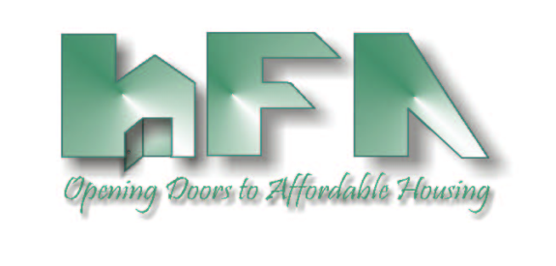
HOUSING FINANCE AUTHORITY OF HILLSBOROUGH COUNTY
AGENDA
9:30 a.m. Friday, August 26, 2022, The County Center, 18th Floor

- 9:30 A.M.: CALL TO ORDER, ROLL CALL & PLEDGE OF ALLEGIANCE

- STATEMENT
Welcome to a Board Meeting of the Housing Finance Authority of Hillsborough County. All meetings of the Authority are open to the public. Anyone who might wish to appeal any decision made by the Authority regarding any matter considered at the meeting is hereby advised that they will need a record of the proceedings, and for such purpose, they may need to assure that a verbatim record of the proceedings is made which will include the testimony and the evidence upon which such appeal is to be based. When addressing the Authority, please state your name and address and speak clearly.

- MINUTES
- Consider Approval of May 13, 2022, Minutes

- PUBLIC COMMENTS
- Speakers must provide their contact information and topic of their concern/presentation.
- Each individual is limited to a maximum of 3 minutes.

- FY 2022-2023 Budget
- Consider Adoption of Continuing Budget Resolution

- MONTHLY FINANCIAL STATEMENTS & INVESTMENTS
- Consider Approval of May, June & July 2022 Financial Statements
- Update on Investments

- BOND ALLOCATION
- Consider Adoption of MCC Resolution and Ratification of Publication of Notice of Conversion

- SINGLE FAMILY PROGRAMS
- Consider Reduction of MCC Rate from 50% to 25%
- DPA and TBA Loan Program Update

- RENTAL DEVELOPMENTS
- Consider Approval of 2023 Bond NOFA and Application
- Consider Approval of Casa Bel Mar Amended and Restated Inducement Resolution
- Consider Directing ED to Explore Potential for Interlocal Agreements to Use Expiring Bond Allocation
- Update on Upcoming Financings
- Update on Existing Rental Developments

- LOCAL GOVERNMENT CONTRIBUTION FOR 9% HOUSING CREDITS
- Consider Approval of Proposed Change to Unit Mix for Andrew Landing
- Consider Approval of NOFA and Application for LGAOF

- SPECIAL PROGRAMS
- Up & Out Homeless Program, Youth Aging Out of Foster Care Program & Catholic Charities Program
- USF CRED Training—Consider Extension Request
- Consider New Life Village Request
- Consider Increase to Rental Subsidy Amount for FY 2022-2023
- Update on Salvation Army Program

- REPORTS
- Sadowski Education Effort/Legislative Update
- Florida Housing Finance Corporation
- Hillsborough County

- NEW BUSINESS
- Consider Sponsorship of FCDA Conference
- Consider Letter of Support for Reappointment of Debra Koehler

