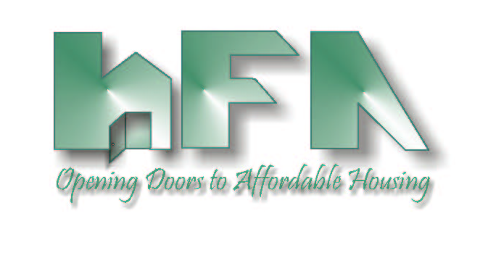
HILLSBOROUGH COUNTY
HOUSING FINANCE AUTHORITY

Board Members: c/o Mary Helen Farris, Esq.
Edward A. Busansky, Chairman Hillsborough County Attorney's Office
Frank D. DeBose, Vice Chairman 601 East Kennedy Blvd., 27th Floor
Tammy Haylock-Moore, Secretary Tampa, FL 33602
Harry S. Hedges www.hillsboroughcountyhfa.org
David A. Hollis
Michael F. Kelley
Debra F. Koehler

DATE: March 8, 2023

TO: Board of Directors
Housing Finance Authority of Hillsborough County

FROM: Mark Hendrickson

SUBJECT: Agenda, March 17, 2023, Meeting of the Housing Finance Authority of Hillsborough County Board of Directors

Location: Planning Commission Board Room
County Center, 18th Floor
601 East Kennedy Boulevard
Tampa, FL 33602

Enclosed is the Housing Finance Authority (HFA) Agenda for the Board meeting scheduled for Friday March 17, 2023, at 9:30 a.m.

Please call Mark Hendrickson at (850) 671-5601, if you have any questions.

This is an in-person meeting. There will not be a conference line for the public.

HOUSING FINANCE AUTHORITY OF HILLSBOROUGH COUNTY
AGENDA
9:30 a.m. Friday, March 17, 2023, The County Center, 18th Floor

- 9:30 A.M.: CALL TO ORDER, ROLL CALL & PLEDGE OF ALLEGIANCE

- STATEMENT
Welcome to a Board Meeting of the Housing Finance Authority of Hillsborough County. All meetings of the Authority are open to the public. Anyone who might wish to appeal any decision made by the Authority regarding any matter considered at the meeting is hereby advised that they will need a record of the proceedings, and for such purpose, they may need to assure that a verbatim record of the proceedings is made which will include the testimony and the evidence upon which such appeal is to be based. When addressing the Authority, please state your name and address and speak clearly.

- MINUTES
- Consider Approval of February 3, 2023, Minutes

- PUBLIC COMMENTS
- Speakers must provide their contact information and topic of their concern/presentation.
- Each individual is limited to a maximum of 3 minutes.

- MONTHLY FINANCIAL STATEMENTS & INVESTMENTS
- Consider Approval of January & February 2023 Financial Statements
- Update on Investments

- BOND ALLOCATION

- SINGLE FAMILY PROGRAMS
- Consider Reduction in DPA Amount for Loans in City of Tampa
- DPA and Loan Program Updates

- RENTAL DEVELOPMENTS
- Update on Upcoming Financings & Existing Rental Developments

- LOCAL GOVERNMENT CONTRIBUTION FOR 9% HOUSING CREDITS
- Update on FHFC Selection of Lake Bluetail

- SPECIAL PROGRAMS
- Up & Out Homeless, Youth Aging Out of Foster Care, Catholic Charities, New Life Village & Salvation Army Programs
- Consider Contract Amendment for Metropolitan Ministries

- REPORTS
- Sadowski Education Effort/Legislative Update
- Florida Housing Finance Corporation
- Hillsborough County

- NEW BUSINESS
- Consider Approval of Sponsorship for NALHFA Conference

